American Basswood (*Tilia americana)*

**Overview**

American lindens or basswoods (*Tilia americana)* wereformerly in the Tiliaceae family but are now members of the Malvaceae family. After recent advancements in genetic studies, the switch was made. However, there is still debate surrounding the North American *Tilia* genera. The Malvaceae family (or Mallow family) includes about 85 genera and 1500 species worldwide, of which 27 genera are found in North America. Hollyhock, hibiscus, and cotton are all part of the Mallow family as well. The family is know for its funnel-shaped flowers with 5 petals and a column of stamens surrounding the pistil. The flowers also have 3-5 partially fused sepals surrounded by many bracts.

**Common Names:** American basswood, American linden, Lime tree, Bee tree

Fun Fact about the name Bee Tree: Linden honey is a famous honey known for its strong flavor (it is known as Lime honey in the UK). Ned Friedman, the director here at the Arboretum, has a hunch that the nectar in the flowers ferments resulting in an almost drunk effect on the bees that pollinate it. The flower structure allows the nectar to be retained and makes it difficult for rain to wash it away.

American basswood trees are generally 18-30m tall (or 60-100ft). It is recognized by its alternate, 2-ranked, heart-shaped leaves with asymmetric bases, its narrowly ridged and furrowed bark, and the leafy bract that often surrounds the fruits and flowers. It is native to North America and ranges from New England through Ontario, Quebec and southeastern Manitoba, south all the way to Oklahoma, east through North Carolina, and north to New Jersey. There are some disjunctive communities in Texas. The American basswood grows best in deep, moist soils so it is predominantly found in the Great Lakes regions of the range but is commonly planted as a shade tree in urban settings.

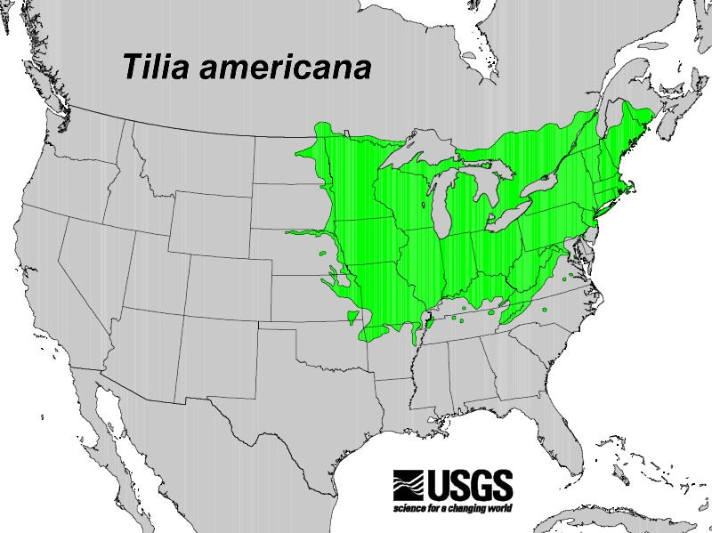

**Restoration:** Basswood trees are frequently planted as ornamentals for their beautiful and fragrant flowers. They are known for enriching the soil by bringing up calcium and magnesium from its deep root system and depositing the nutrients into the leaf litter on the ground.

**Description:** It is a deciduous tree with a single, erect trunk without or very few branches halfway up the trunk. The crown is ovoid with many slender branches to provide ample shade cover. The leaves are thick, slightly leathery, with shallow toothed margins, are mostly hairless with occasional sparse hairs sometimes occurring on the underside of the leaf. The flowers are yellowish-white, in clusters of 6-20 drooping flowers hanging on the stalk near the bract. Fruits are mostly round, 8-10mm wide, hard and dry.

Some experts debate that there are multiple subspecies, most commonly argued that there are two varieties of American basswood: var. *americana* and var. *caroliniana.* The former is known for little to no hairs on the lower surface that are sparse and rusty in color, whereas the latter has dense white hairs on the under surface of the leaf. However, each characteristic has been found on the same individual tree... even more taxonomic debate!

Kyle Port, the manager of the plant inventory of the Arnold Arboretum, did a tour last year in July and Suz took some notes from that. Kyle mentioned that the leaves tend to have more holes in them due to the fact that they don’t have a lot of toxins to kill off insects. The fruit is known as a “psuedosamara” because of the bract shape, which is reminiscent of a samara – a samara being the helicopter/bunny ears seen on the Maple trees. The nutlets formed typically have two chambers inside with individual embryo in each chamber. However, one of the embryos usually aborts resulting in one seed, or nutlet. The nuts will shatter when ripe. Lindens are monoecious, meaning they have both the male and female parts, but they are not self-compatible, so when pollen is released from the anther, the pistil will not be ready to receive it for several days.

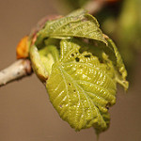

**Flowering and Fruiting-**The fragrant, yellow-white, perfect flowers generally start flowering in June but can begin in late May or early July. Flowering typically lasts about 2 weeks. The flowers attract a number of insect pollinators. One study identified 66 species of insects from 29 families as pollinators of the lindenflowers. However, bees and flies were the most common pollinators, but moths were frequently seen pollinating at night.

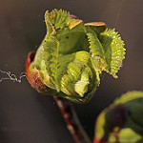

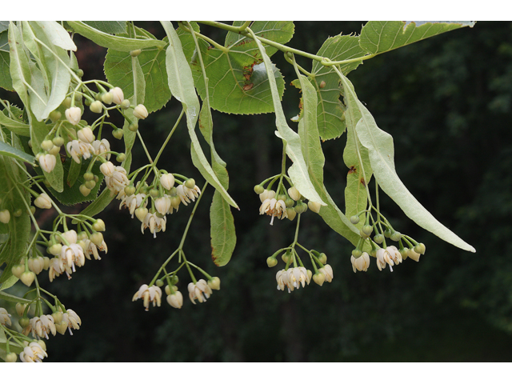

**Propagation:** Ripe fruits generally are dispersed through wind, gravity and animals in September and October. The bracts help with the wind dispersal; however, they aren’t typically carried further than one to two tree lengths away. Seed-bearing age is anywhere from 15-100 years for the American basswood, but seed production has been seen as early as 8 years of age. Untreated seeds germinate in 2-3 years or can germinate in about 40 weeks if cold stratified.

American basswoods are often found near Sugar maples. The basswoods are known for establishing a lateral root system quickly and having rapid sprout growth, resulting in less competition with the Sugar Maple for sunlight. The Sugar Maple is more shade tolerant than the American basswood.

**Why study this species?**

American basswoods are labeled as a USA-NPN regional plant species, meaning it is ecologically and/or economically important to the region. Therefore, it makes it crucial to understand the effects of anthropogenic climate change on the phenology of the American basswood. On top of that, the basswood is a common allergen, making observations all the more valuable to provide information regarding public health in the community.

**References:**

**https://www.usanpn.org/nn/Tilia_americana**

[**https://www.na.fs.fed.us/pubs/silvics_manual/volume_2/tilia/americana.htm**](https://www.na.fs.fed.us/pubs/silvics_manual/volume_2/tilia/americana.htm)

[**http://www.wildflower.org/plants/result.php?id_plant=TIAM**](http://www.wildflower.org/plants/result.php?id_plant=TIAM)

[**http://tcpermaculture.blogspot.com/2012/05/permaculture-plants-lime-linden-and.html**](http://tcpermaculture.blogspot.com/2012/05/permaculture-plants-lime-linden-and.html)

[**http://homeguides.sfgate.com/trees-nectar-pollen-honeybees-65869.html**](http://homeguides.sfgate.com/trees-nectar-pollen-honeybees-65869.html)

[**http://www.kansasnativeplants.com/guide/plant_detail.php?plnt_id=596**](http://www.kansasnativeplants.com/guide/plant_detail.php?plnt_id=596)

**https://www.usanpn.org/files/npn-viz-tool/**